2018 SWOCC ELLIOTT STATE FOREST RECREATION PLAN
W/RECOMMENDATIONS

May 29, 2018 Deans Mountain Field Trip

This field trip examines the evolution from canoe routes and foot trails to and through the Elliott that existed since precontact time, to pack trails, wagon roads, logging roads, and modern highways that exist today. Tour guides will be Bob Zybach and David Gould; Jerry Phillips will be unable to attend, but references to his book are given for most stops.

Mill Creek Log Dump. Head of tidewater, in common with Scottsburg and Allegany. Beginning point of precontact foot trails to Loon Lake, Allegany, Tenmile Lakes, Winchester Bay, and Reedsport. Likely location of homesites and/or campgrounds: lunar vs. solar daily time. Sawmill and white settlers in 1850, ship building, ended with 1861 flood (Phillips 1998: 391-393).

Indian Point Trail. Part of a series of “Indian Allotments” along Mill Creek, said to have been occupied by the “Umpqua Johnson” Indian family, who later moved to Reedsport and Siletz. They were said to be living in this location during the 1868 Coos Fire and saved themselves by submerging their bodies in the creek. Huckleberries, fishing location, and logging road along ridgeline conform with other Indian homes along the Oregon Coast (Phillips 1998: 392-393).

Cougar Pass Lookout. Named by an Ash Valley hunter for the cougar(s) he killed in this location. Lookout tower was built in 1935 by the CCCs as their road construction work reached this location. Water source, as typical with ridgeline trail network, is only 200 feet below the road, at the headwaters of Cold Creek. The tower is still standing, but has not been in use for more than 30 years (Phillips 1998: 92-94).

Deans Mountain Lookout. One of the very earliest fire lookouts in Oregon, built between 1910 and 1914, Phillips regards this as “the most famous place” in the Elliott because of this statewide renown. The freshwater source was on the west side of the hill and is known as the “Scholfield Waterhole.” Deans Mountain has a long and colorful history and is one of the few places in the Elliott from which the ocean can be seen (Phillips 1998: 58-61, 82-88).

Old-Growth Mix. Unusual pre-1868 Coos Fire mixed old-growth conifer stand of Sitka spruce, Douglas fir, western redcedar, and western hemlock. “Old-growth” red alder also present.

Automobile tours and photography through the Elliott by local expert (4 blog posts: 31 pages):
http://www.orww.org/Elliott_Forest/Recreation/Field_Trips/Hargan_20160000.pdf

Coquille Indian research report on Indian trail history and locations southward from Allegany:
http://www.orww.org/Coquelle_Trails/References/Zybach-Ivy_2013/index.html

Historical, cultural, and ecological importance of Oregon Coast Range Indian trail history:
http://www.orww.org/Coquelle_Trails/References/Braman_1987/index.html

Phillips’ history of the Elliott State Forest (414 pages):
http://www.orww.org/Elliott_Forest/History/Phillips/Phillips_1998-201.pdf
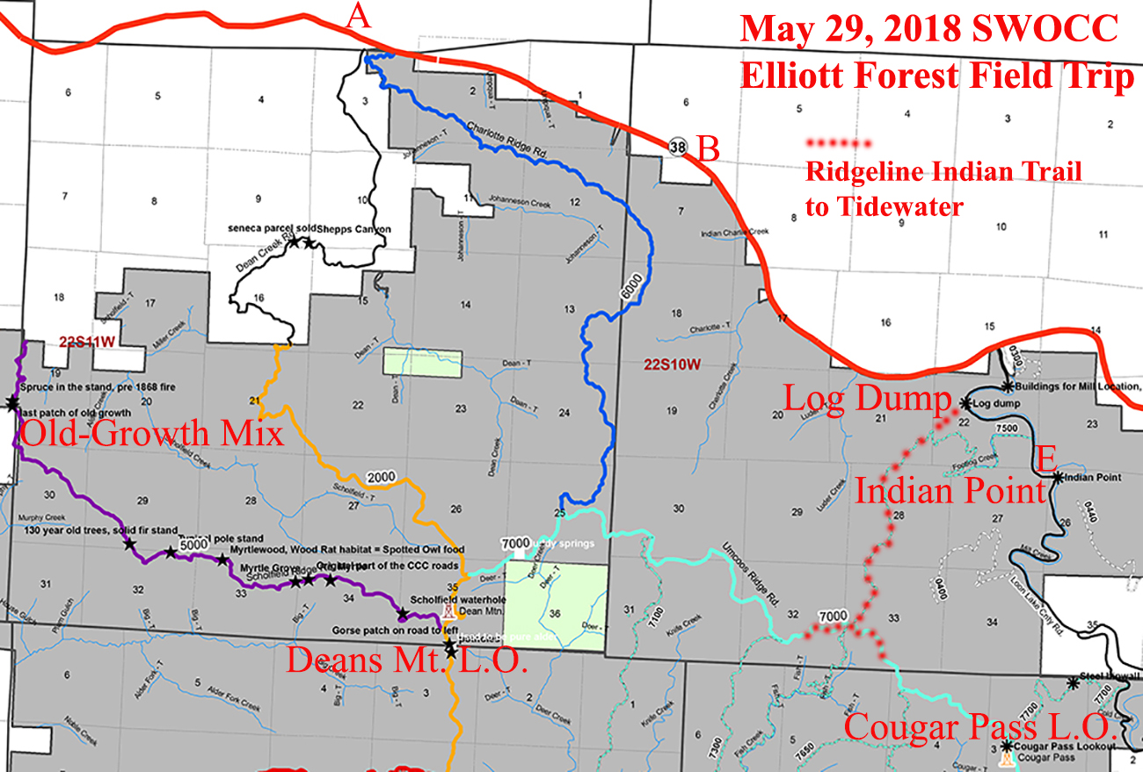
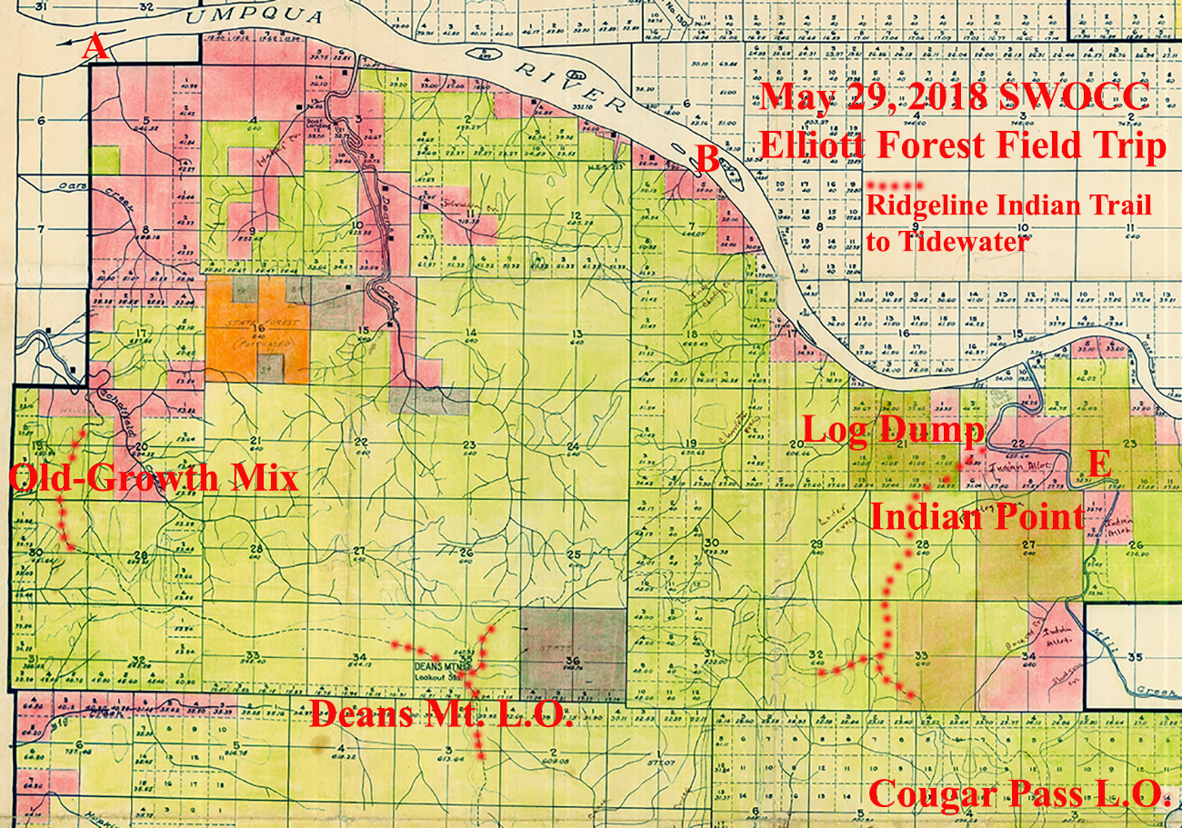

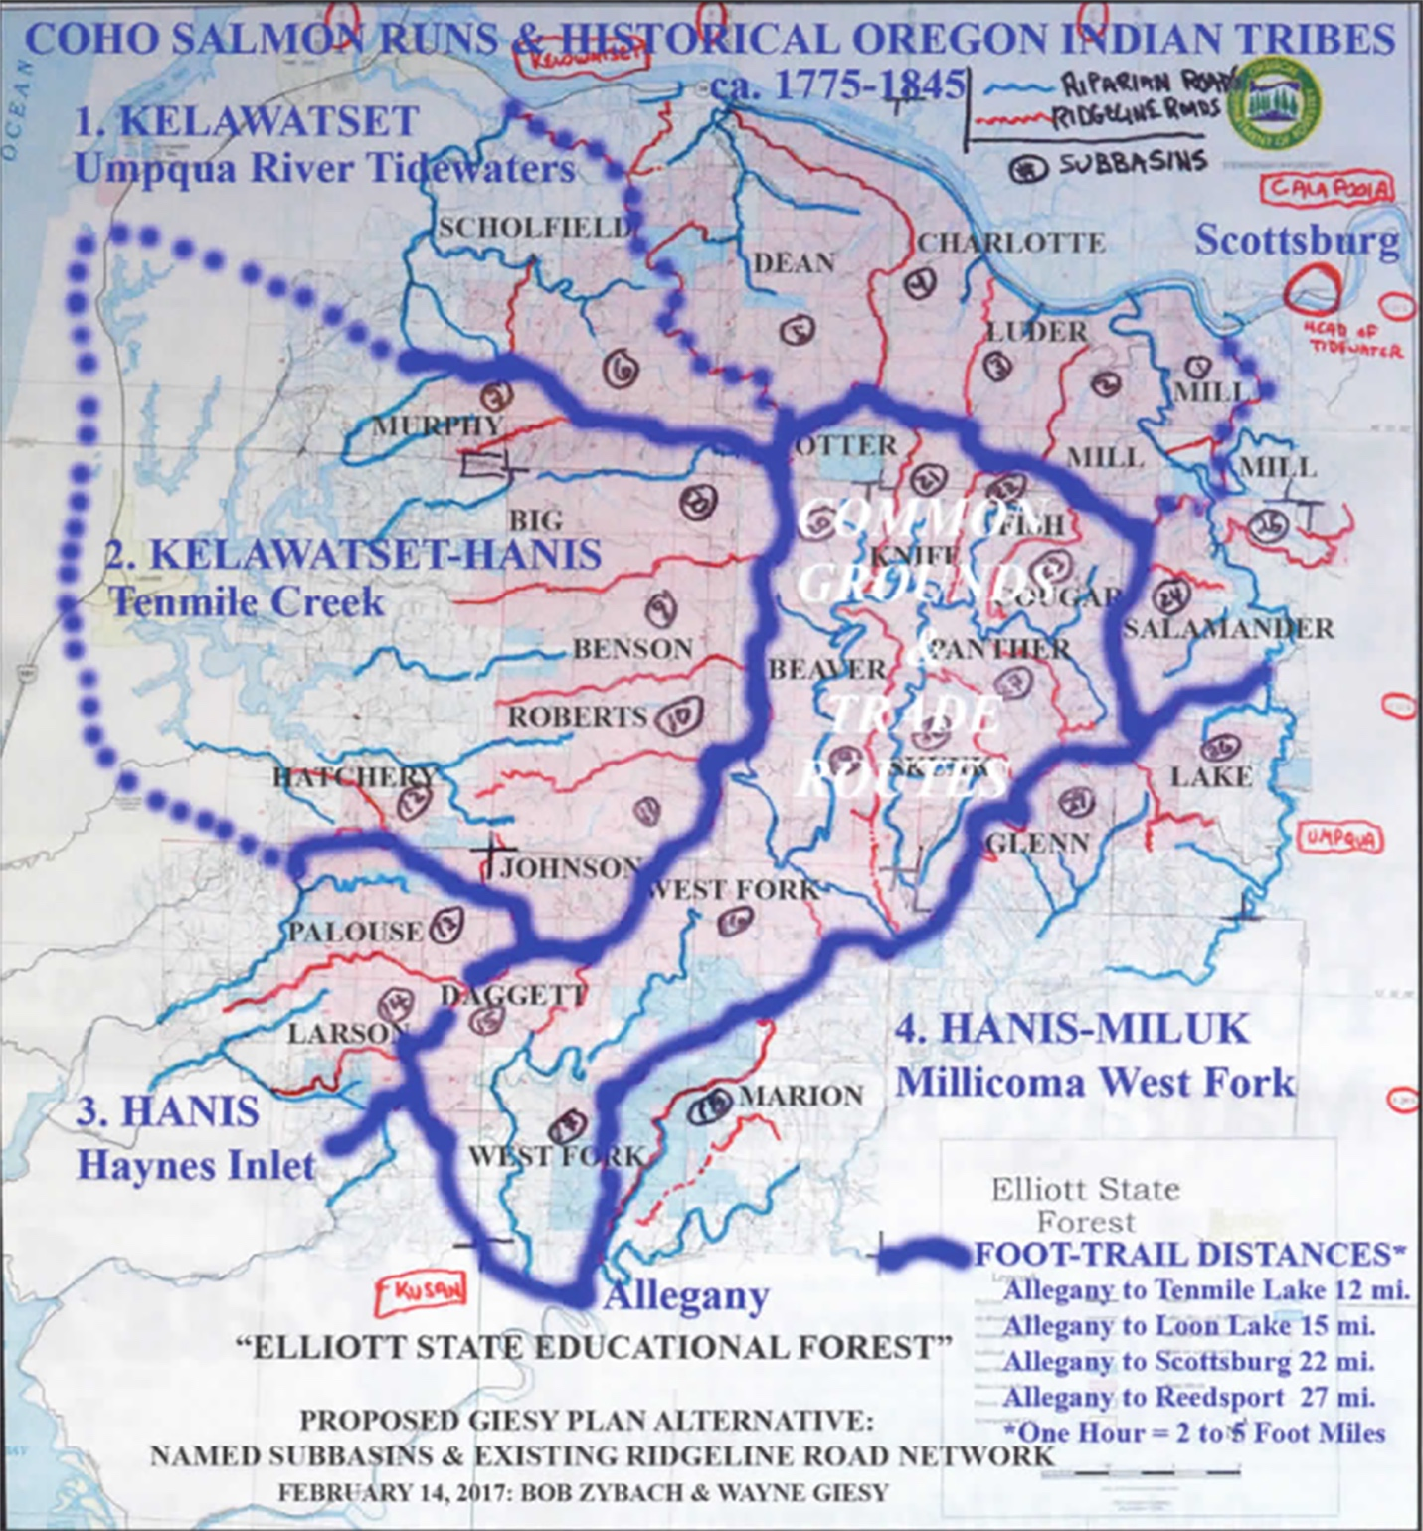

This map shows the theoretical “ridgeline trail” network of local precontact Indian tribes, connecting the head of tidewaters on the Coos and Umpqua Rivers with each other and with the Tenmile Lakes area by foot trails. By probable coincidence, Phillips’ map of the Elliott’s “Historic Foot Trails” (Phillips 1998: 18) shows nearly identical routes. The subsequent map of the “Allegany District” shows the documented Indian foot-trail network to the south of Allegany (Zybach and Ivy 2013: 25) – and directly connecting to the Phillips map (below) and Zybach-Giesy map (above) with head-of-tidewater Allegany as their southern-most point. NOTE: The currently preferred reference to the early historical Lower Umpqua/Kelawatset Tribe is “Quuiich” (Patricia Whereat Phillips: personal communication).

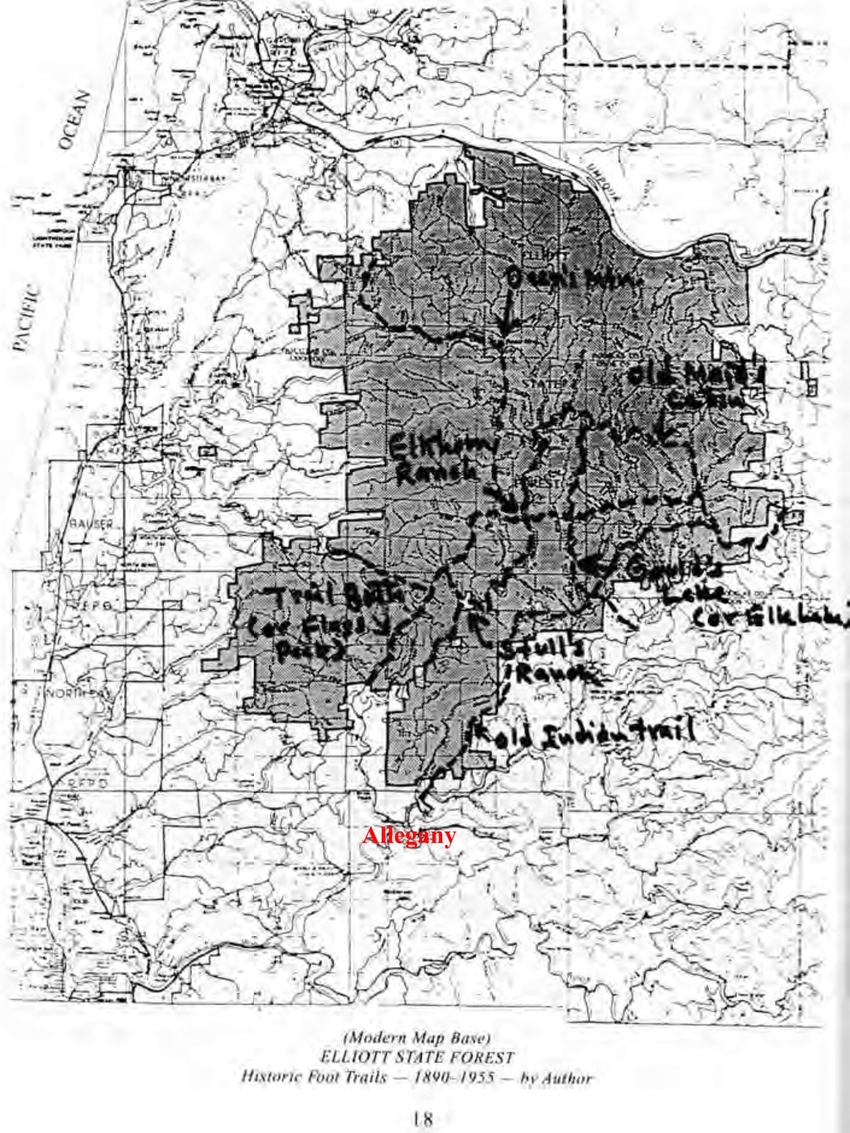
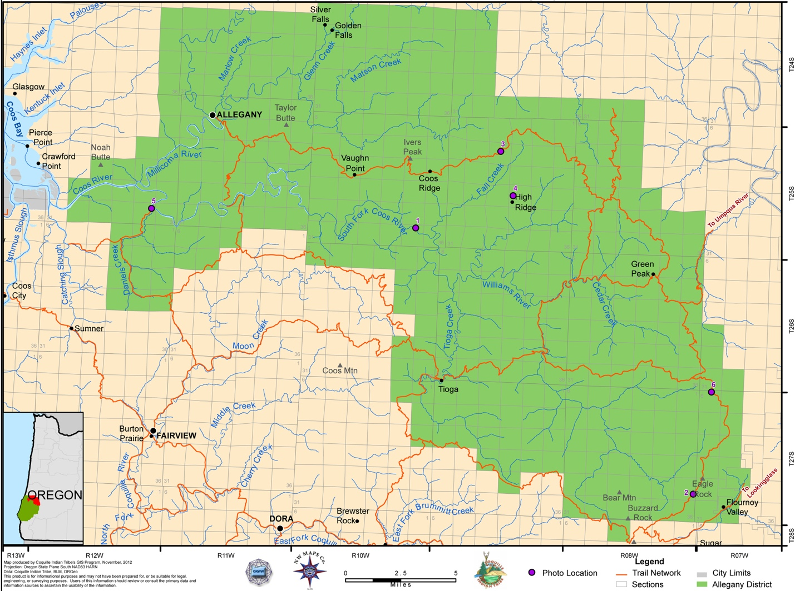
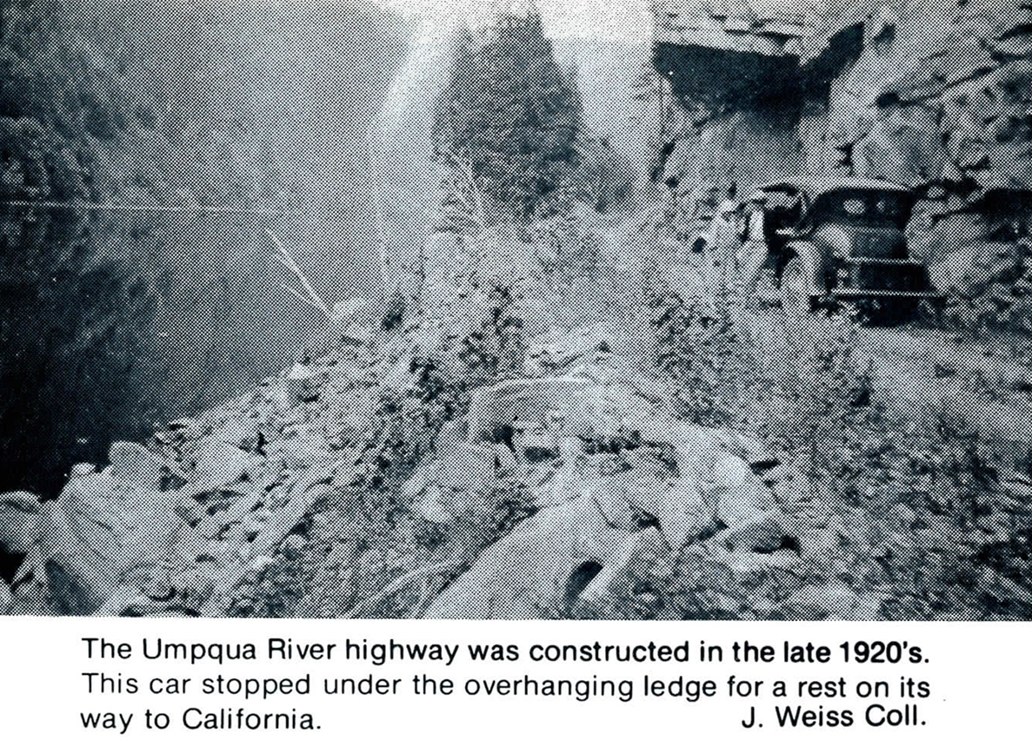

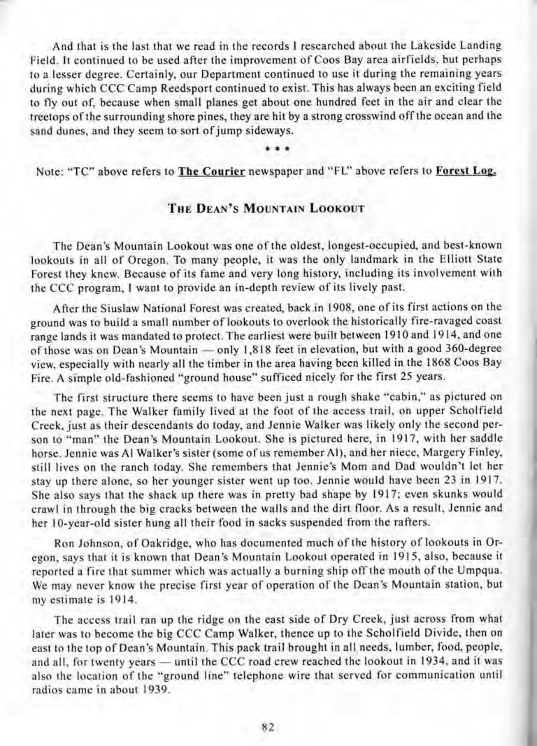
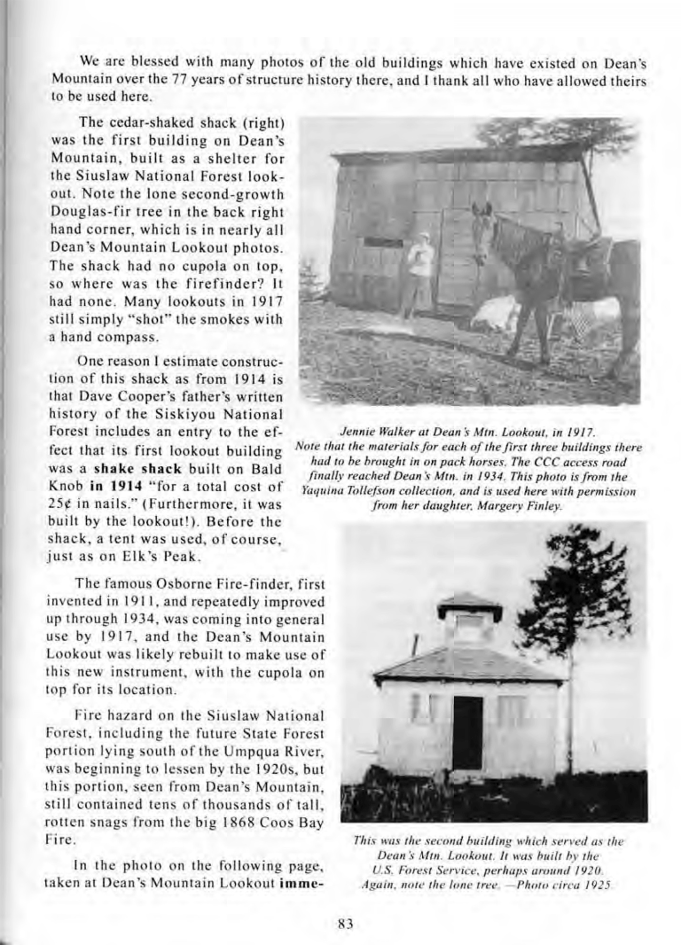
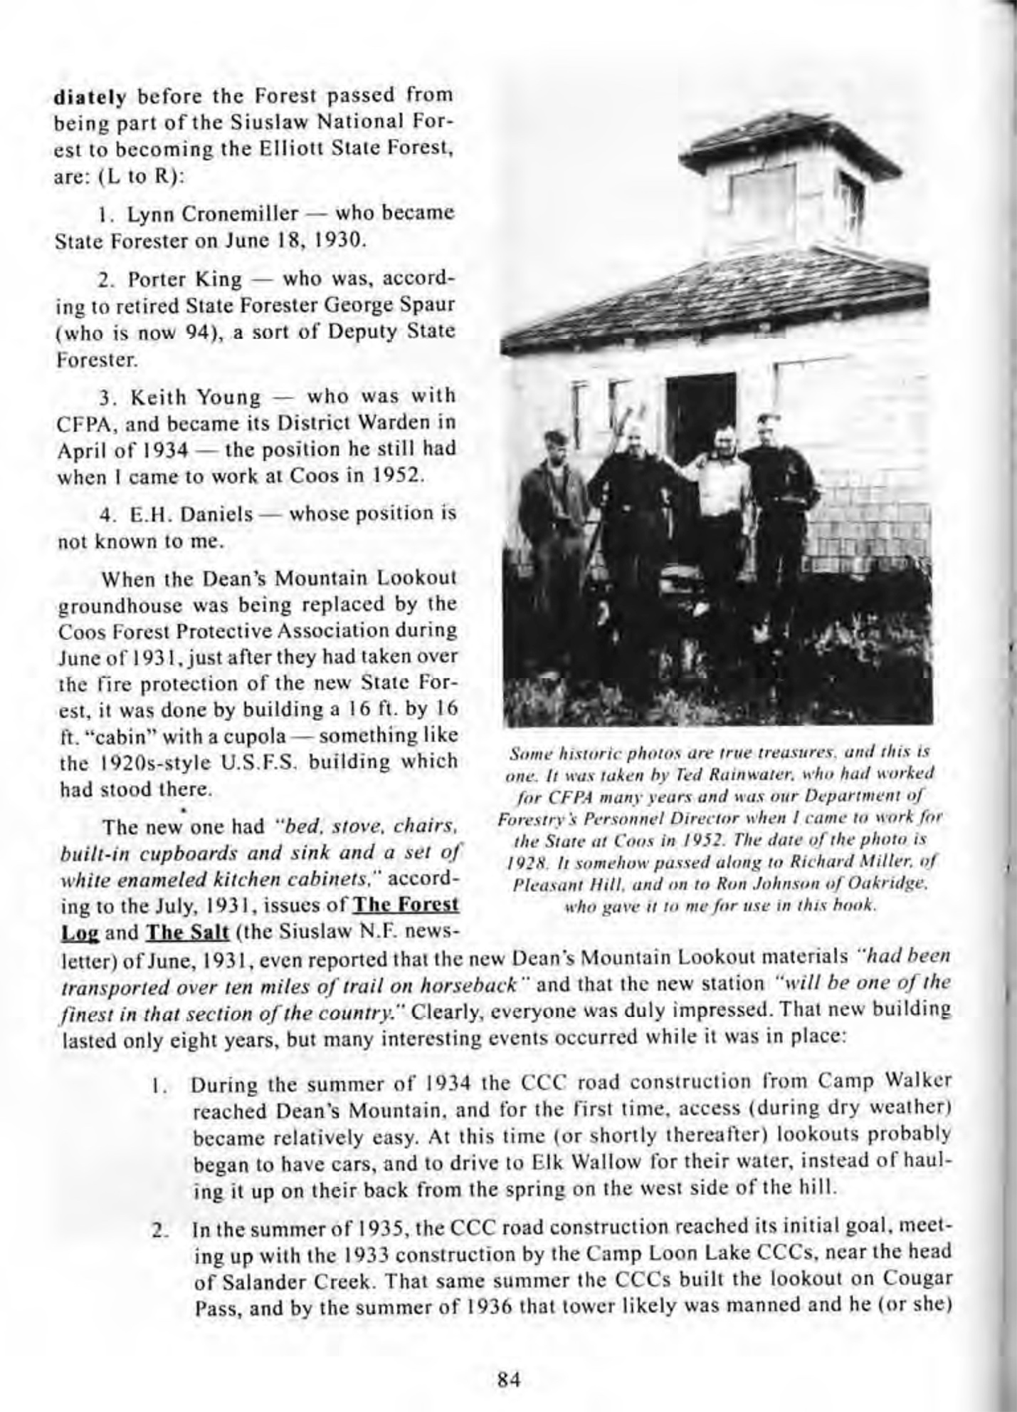
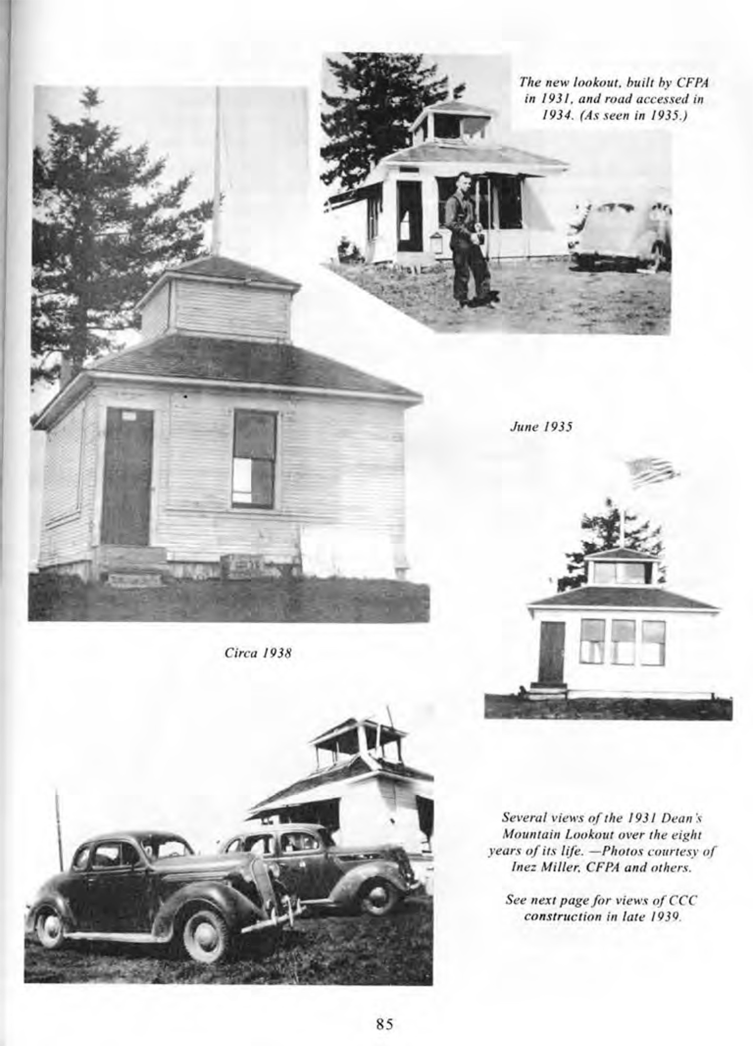
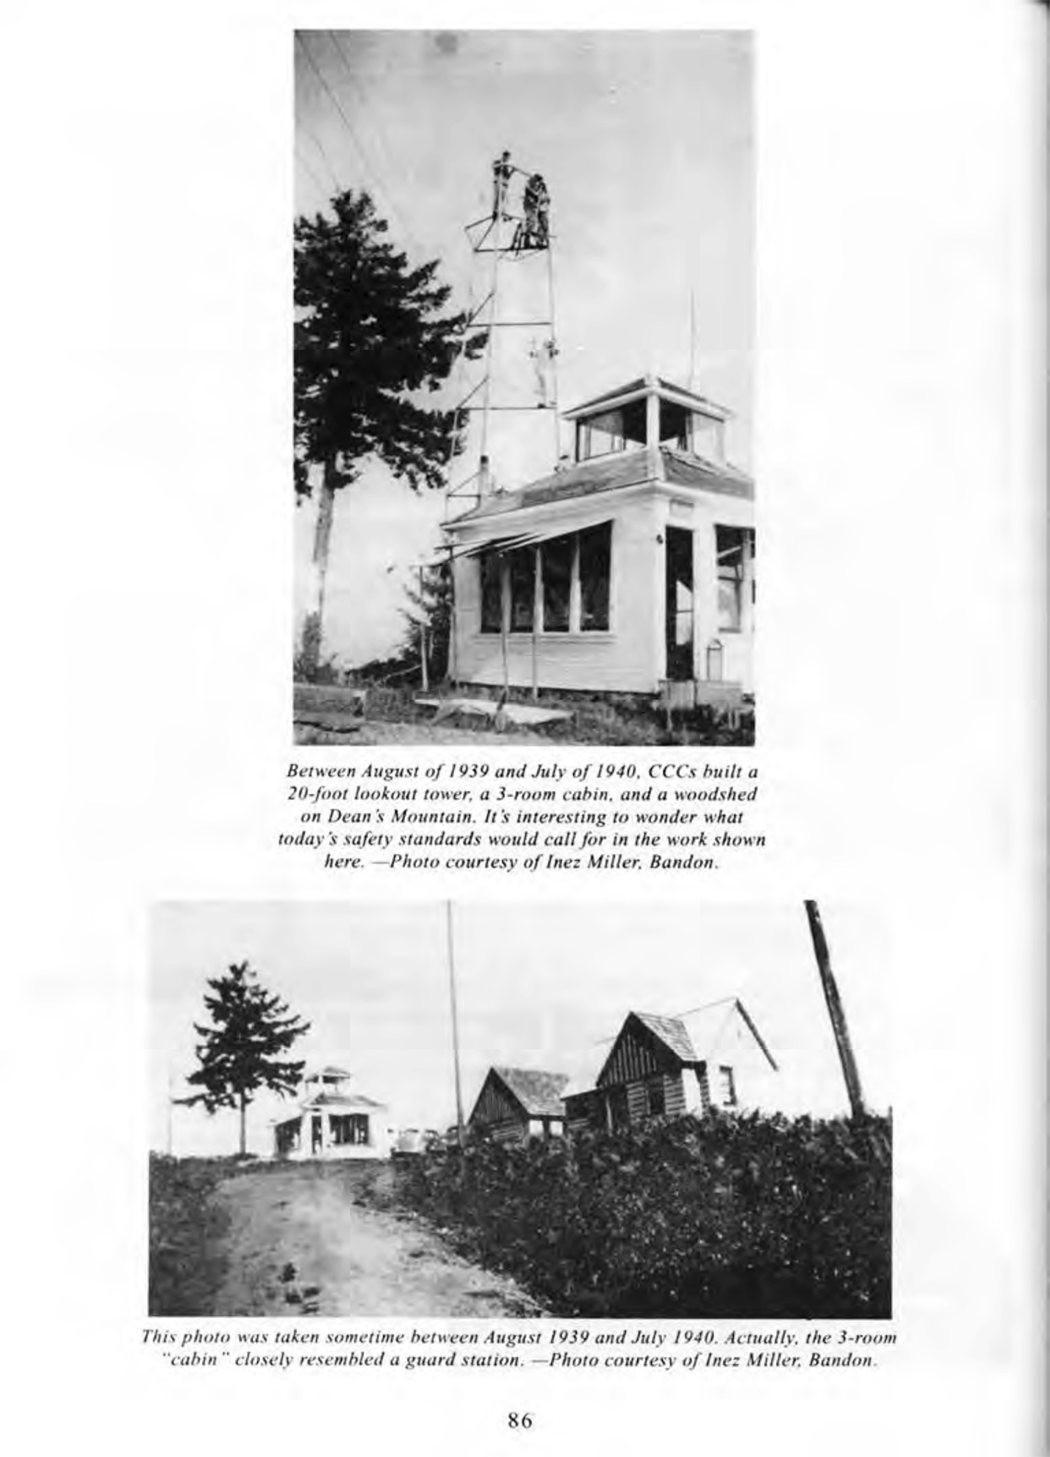
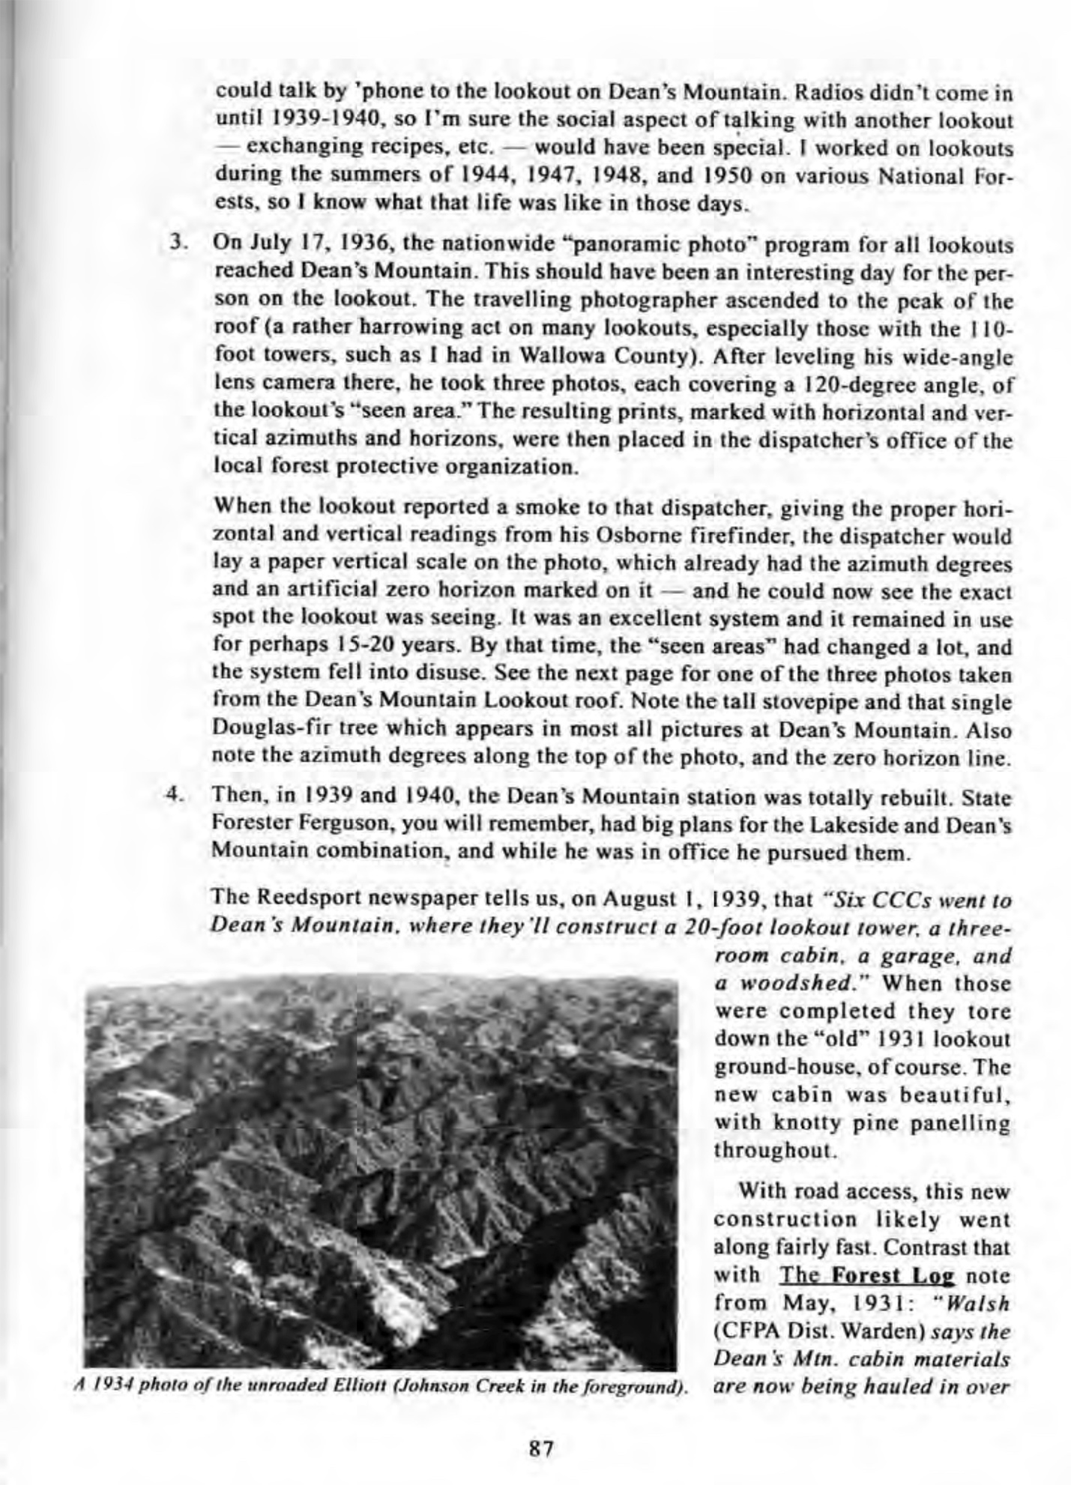
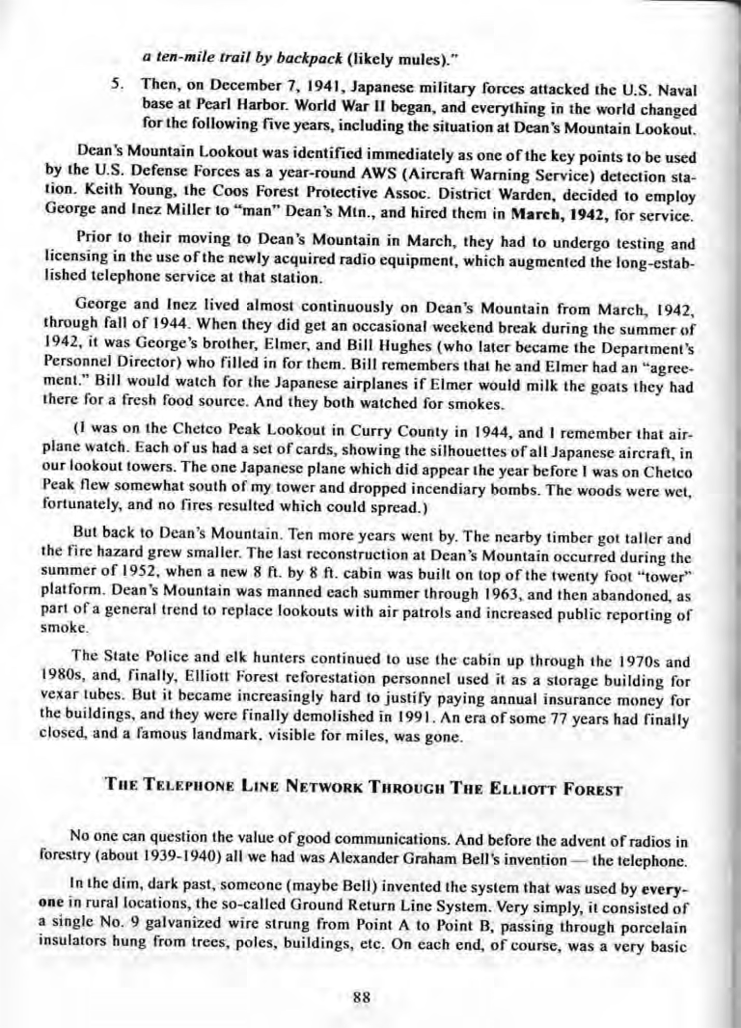
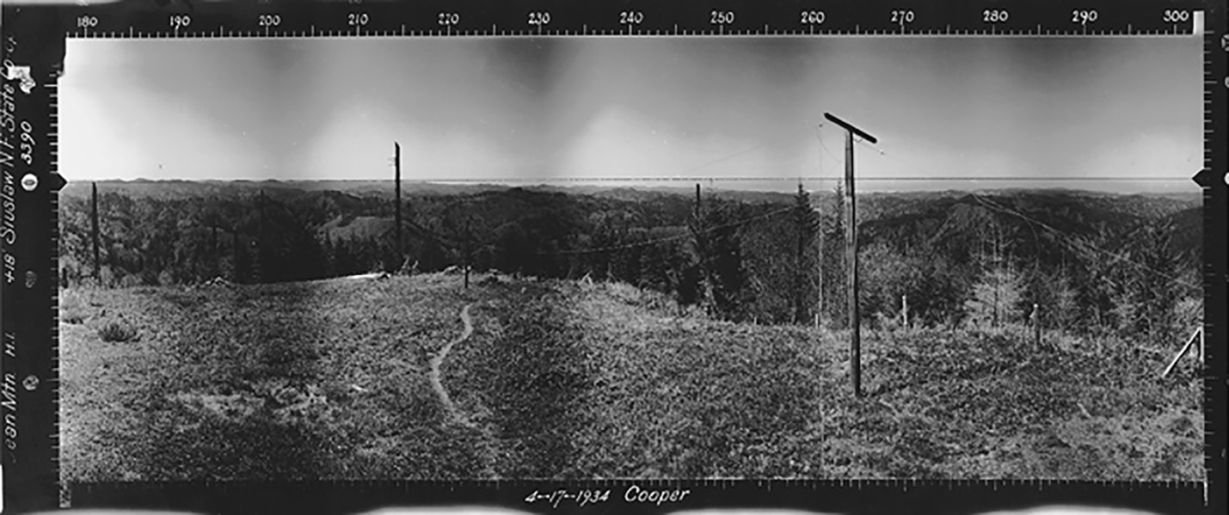

The “Osborne” Fire Lookout photo, above, was taken April 17, 1934 by Robert L. Cooper, hired out of OSC forestry school in 1933 by the Civilian Conservation Corps (CCC) to help complete this project on all western US forests. The 270-degree mark on the photo points due west; the color photo (below) is taken from approximately the same vantage point with an iPhone on December 6, 2017 and is also facing due west. Note the ocean on the horizon and glimpses of sand dunes – also the telephone poles in 1934 (Phillips 1998: 88-91).

