2018 SWOCC ELLIOTT STATE FOREST RECREATION PLAN
W/RECOMMENDATIONS

May 8, 2018 Recreation Plan Outline & Draft

WORD; PHOTOSHOP; PDF; HTML – [MP3; MP4; ADOBE ACROBAT; DREAMWEAVER]

Peer Review process: 1) within group; 2) instructors; 3) outside experts = final draft/report

A. TITLE: Start with above; add “Draft” to title
B. PREPARED FOR: Tasha and SWOCC Forestry class – DSL? Public?
C. PREPARED BY: Alphabetical? Seniority?
D. ACKNOWLEDGEMENTS: Tour guides, hosts, reviewers & affiliations

E. INTRODUCTION [EXECUTIVE SUMMARY?]: Description and maps of Elliott Forest location; project history and intent; recreational opportunities; landowner restrictions; plan organization; Other?

F. TABLE OF CONTENTS [“INDEX”]: Table of Figures; Table of Maps; Table of Tables

G. PURPOSE AND NEED: To make a plan for academic credit and public review & because one doesn’t exist and public safety and education, local recreational opportunities, need to be addressed.

H. SOURCES OF INFORMATION (METHODOLOGY): local experts; literature review; eyewitness observations/documentation. Other? Table?

I. CHAPTERS (Order? 1000-1500 words max.; min. 1 photo; 1 map; 1 quote; 3 PDF references)

Group 1: 02-Local Forest Recreation Opportunities (Mike Mader; Bob Mahaffey; Cathy Reiss)
03-Camping (Riley Ranch hosts) [and boating?]
12-Recreation Economics (Cathy Reiss; Antonio Salgado) [job types/income]
Group 2: 04-Forest History (Jerry Phillips; Phillips 1998; David Gould; Rickard 1982; Youst 2011)
06-Cultural Resources (Phillips 1998: 372-395; Amber Ross)
08-Fish Habitat/Access (Gary Vonderohe; Mike Mader) [and drones?]
Group 3: 07-Fish Hatcheries (Antonio Salgado; Gary Vonderohe)
10-Hunting/Trapping (David Gould, Lionel Youst; Mike Mader)
11-Ethnobotany (Patty Whereat; Bob Mahaffey; Mike Mader)
Group 4: 01-Forest Roads and Trails (David Gould; Jerry Phillips; Amber Ross)
05-Sightseeing/Aesthetics (Marty Giles; Anne Matthews) [radio towers?]
09-Birding (Marty Giles)
Boating? Drones? Ziplines? Other?

J. GENERAL SUMMARY & RECOMMENDATIONS: Report summary, consensus, bullet points

K. REFERENCES PDF Files (author year: pp.; author-author year: pp.; author, et al. year: pp.)

L. APPENDICES[?] Field Trips? Promotional literature? Latin names? School Trust?

M. OTHER?

CHAPTER OUTLINES

Peer review: Share with two team members as hardcopy, revise, and give to instructor.

Next, revise and submit to willing local experts for feedback/criticism

1. Select a photograph that represents the chapter topic [PhotoShop/Caption]

2. Select a base map for the chapter [PhotoShop/Caption – GIS?]

1,000 to 1,500 words (min. 1 quote, 3 PDF cites; tabular entries count, captions don’t)

3. “Mike’s Fluff” paragraph (definition of topic, application to Elliott, no goals)

4. Current use on Elliott (cite best estimates and/or agency data available)

5. Potential for School Trust advantage (personal assessment, reviewed)

6. Barriers to development (2-4 actual/potential problems to improvements)

7. Recommendations for/against development/use (2-4 personal suggestions)

8. References (don’t add to word count; cites w/n text do)

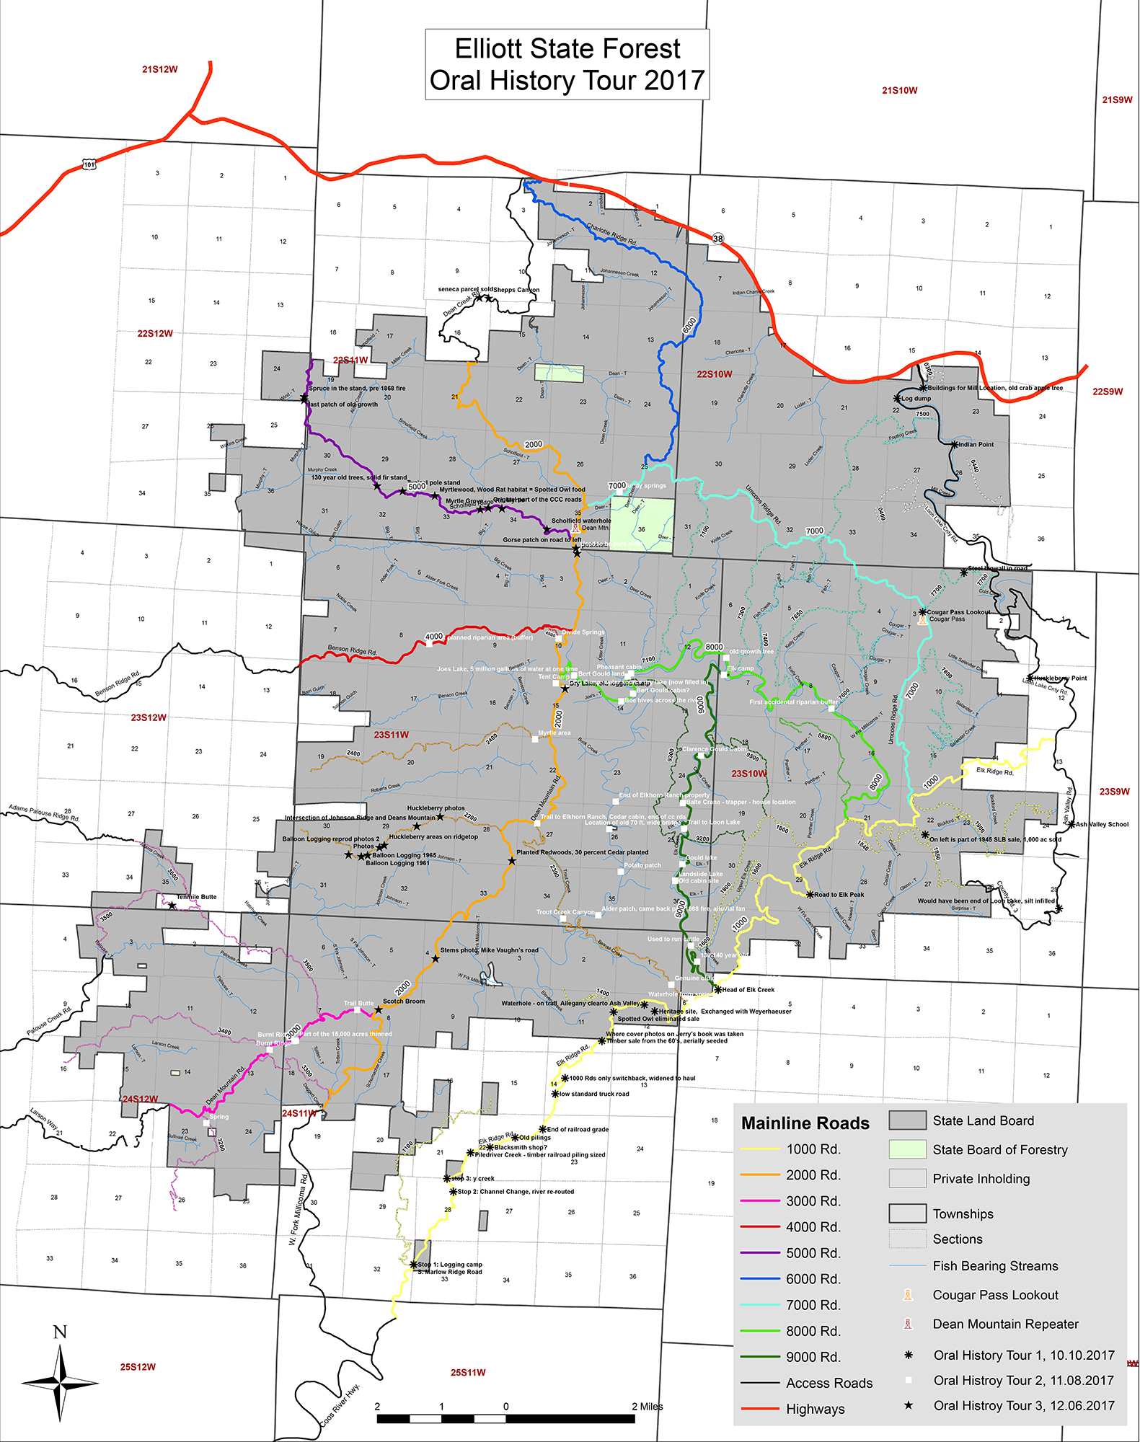

STUDENT FIELD TRIPS ASSESSMENT

A. FIELD TRIP #1 ELLIOTT FOREST INTRODUCTION: HISTORY AND ACCESS

WHAT WERE TWO BEST PARTS OF THE FIELD TRIP?
1.

2.
WHAT WERE TWO WORST PARTS OF THE FIELD TRIP?
1.

2.
WHAT WOULD YOU RECOMMEND TO IMPROVE?

B. FIELD TRIP #2 MILLICOMA STEP FISH HATCHERY: ENHANCED SPORTFISHING

WHAT WERE TWO BEST PARTS OF THE FIELD TRIP?
1.

2.
WHAT WERE TWO WORST PARTS OF THE FIELD TRIP?
1.

2.
WHAT WOULD YOU RECOMMEND TO IMPROVE?

C. FIELD TRIP #3 TENMILE LAKES: LOCAL RECREATIONAL BUSINESSES

WHAT WERE TWO BEST PARTS OF THE FIELD TRIP?
1.

2.
WHAT WERE TWO WORST PARTS OF THE FIELD TRIP?
1.

2.
WHAT WOULD YOU RECOMMEND TO IMPROVE?

